1. Create a new Unity 3D project and import the provided sound clip files.
2. Import Oculus Audio Spatializer Unity Package into your project. Update and restart Unity if requested.
3. Open Edit | Project Settings | Audio and set both the Spatializer Plugin and Ambisonic Decoder Plugin to OculusSpatializer. Set DSP Buffer to Best Latency.

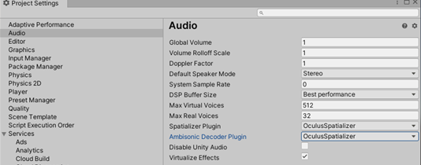

1. Add an AmbiX format ambisonic audio file to your project, several have been included in the folder provided.
2. With the audio file selected, select Ambisonic in the Inspector and Apply.

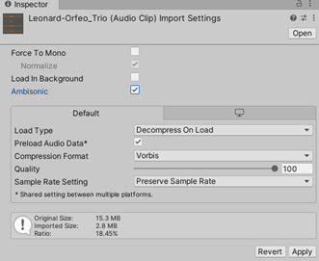

1. Add a GameObject to the scene to attach the sound to.GameObject | 3D Obect | Sphere and name it **AmbisonicSound**
2. Ensure the GameObject **AmbisonicSound** is selectedand add an Audio Source component to your GameObject and drag your audio file to the Audio Clip field.
3. In the Output field, select SpatializerMixer > Master.
4. Ensure the GameObject **AmbisonicSound** is selectedand add the ONSP Ambisonics Native script component to your GameObject. (you might need to type in ONSP in order to find it.) Select the “Use Virtual Speakers” option for the ONSP Ambisonics Native (Script) object.

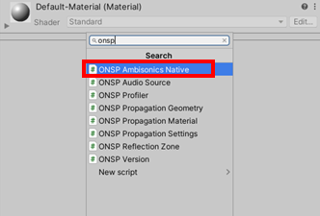

There’s more .. section at the end of the recipe.

<https://forum.unity.com/threads/360-video-with-embedded-ambisonic-audio.510693/>

<https://developer.oculus.com/documentation/unity/audio-osp-unity-ambisonic/>

<https://www.alanzucconi.com/2020/05/19/an-introduction-to-360-videos/>

<https://stefanrichings.com/2018/08/05/ambisonics-in-unity/>

<https://gamedevbeginner.com/vr-sound-design-in-unity-getting-started-guide/>